[listening to most played songs on Spotify 2019]

Dear Diary,

*The first step towards connection is departure*.

It’s always so great to read my diary entries from past years around this time. I love feeling nostalgic around the end of the year.

Reflecting on this year…. Is a bit crazy to do.

[Om Gan Ganapataye Namaha]

It’s sometimes hard for me to reflect on incredibly moving experiences.

Though, I suppose I can start with last night.

I saw Peter last night. I went to his place and did a bunch of whip-its. I met his roommate and a lot of his close friends since they were throwing a party. It was a good time. He knows incredibly warm and welcoming people. It was interesting to picture myself in that scene. If I move here I could easily see myself finding a crowd here.

I have a feeling that Peter is a very special person in my life.

Last night, we didn’t sleep together - because he is dating Michelle.

[Vibin out with (((O)))]

His friends were so intruiging.

They told me a funny prank. If someone is tripping on acid, get a bag of oranges, like peel them and everything, then peel one lemon and eat the oranges in front of people who are tripping until they ask for a slice, then hand them the hidden lemon slices from your bag and watch them pucker up their lips - so funny!

Anyways, so Peter and I chatted a lot in his room, and he’s only exclusive in the sense that he isn’t sleeping with other people.

He still tied me up and we made out and had a good time. He’s such a cool dude. I really don’t know what it is specifically about him, but I keep gravitating towards him.

It was fun being around some older people for a night again. It reminded me a bit of Koh Phangan. I forgot that I was hanging out with people who were exclusively older than me for a while. Oh, and I guess at CU Boulder too.

That’s awesome that I’m always the youngest out of the people I hang out with.

Even now at Yeng and Sam’s place I’m the youngest person too.

It’s so fun being back with the guys, I love it.

I’m definitely doing a LOT of fucking drugs, but it’s okay, I’m going out with a bang before my 100 days.

They start on January 13.

(Or January 11 if I want it to end on 4/20… we’ll see)

I just reread the Medium article I’m about to post about social media and politics. I’m pretty stoked about how it turned out. I think it is a great culmination piece for my semester. I think as long as I put out one solid post per semester (or twice if I’m lucky) throughout my entire PhD, then I’ll be super solid.

Also, quick side note about staying with Yeng and Sam.

I’ve been sleeping in Sam’s bed with him and we are sharing a blanket and its so weird to feel such a balance of

[Liberation]

Feelings for someone (romantically, sexually, etc…) and love for someone (like a brother, best friend, platonic).

I think about Sam so much. He impacts my decisions so much, and I’ve only ever done that with people I love in the past.

Peter told me that he loved me last night. He admitted that he discovered that he is capable of falling in love for a short period of time and with no need for explanation, no need to relive it, just accepting what it was and loving it.

It’s interesting to feel things for men. I have been considering dating women in 2020. Not exclusively, but I’m thinking about getting a dating app and only adding women for a little while. I think it could be good for me to check out what it’s like to be with women. I could see myself liking it.

[Hurricane]

I can’t believe how fast 2019 went.

I did all of my crazy travels that I wanted to experience in life.

I fulfilled practically everything that I didn’t even know I wanted to do before I die.

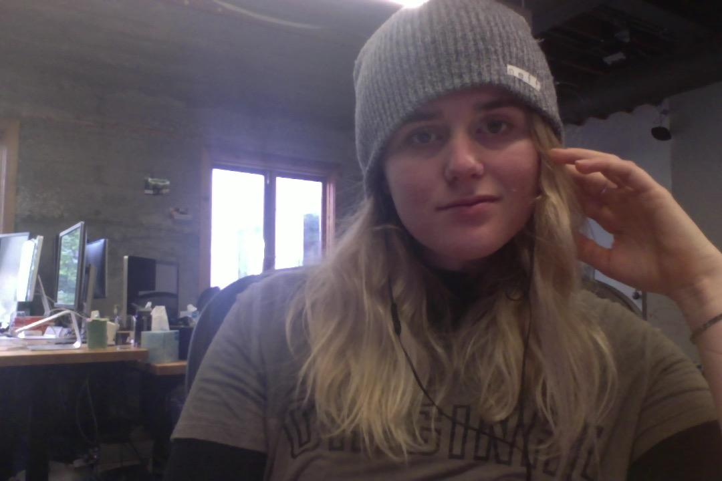

Oh I’m really high by the way. We all waked and baked at Sam and Yeng’s place. I did it with Ryan, Feris, and Yeng.

I’m really excited for Dead Mau5 tonight, we are going to each take like ⅓ tab of acid and start partying at like 3 am and be out until like 8 am.

So anyways, this last year, what can I even say about my travels. I feel like I’m not fully ready to debrief them. I feel like their impact will become more profound the longer that I have lived past them. So far I can feel memories from traveling hit me like bursts of warm, tropical wind.

I remember sitting alone on the front porch area of the Bali bar during sunset. The night that I ordered food from the restaurant that was way too expensive, eating a bit too much, and feeling like shit.

I remember feeling so guilty for staying in my hostel bed all day, and then also not knowing what to do to meet people or socialize.

Yet somehow I ended up sleeping with the Balinesian man and going back to his apartment and not dying…

How the fuck did I do that??

What a crazy time…

Then back on Koh Samui I felt like I fucking ran that town… that was incredible.

I can’t even begin to describe Koh Phangan. What bliss. What eternal happiness. What bávána.

[I’m closing my eyes (ft. Shilo)]

[el lado oscuro]

Thinking about Cali gives me such an interesting emotion.

I miss it so badly, and yet, I’m so glad that it was fleeting.

I wonder if I would have been as fond of Cali if I had been able to stay longer.

Things that have an expiration date are more appealing to me. With travel, with relationships, with practically everything.

Last night I felt me get some of my sexual confidence and courage back inside of me from my travels.

While I was traveling, I felt who I was so much. I loved being confident and on fucking top of my shit. The first night in Rossa Palma was absolutely epic. I can’t believe I started becoming friends with the people who worked there, and then introduced Wesley to them and continued down the family line.

I hope that I’ll be able to go back soon for a visit. I would love to see everyone again and to work on my Salsa and Spanish for a little bit.

Last night Peter was so hot with the ropes… he is really good at doing ties. He was trying this hair tye on me and it was fucking awesome.

When he gets turned on, he growls and he like can’t control it. It just slips out of him, and he kept doing it last night and every time he did it my body was just like *fuck*. It was so wild, I can’t believe how physically and emotionally compatible he and I are. Just in two different phases of life I suppose.

He told me to tell him if I am ready for a committed relationship and he is either single and/or close to single (lol).

[La mujer que bota de fuego]

“All that we are is the result of what we have thought.” - Buddha

I loved being around yogis so much. It felt incredible to just be barefoot and in the sun and in control of my day and knowing so many people, and feeling confident and healed and cleansed and uncontrollably happy.

I was literally smiling at people that I passed on my motor bike until they would smile back at me… that’s WILD!!! I fucking love feeling on top of the world.

I’m fucking ready for that feeling in 2020. 2020 Clarity Baby.

100 days. I can fucking do this.

I think it would be really exciting to live in SF for a little while. I really hope I can land one of these internships.

We’ll see.

[Bedford falls]

I think I’m going to try turning all of my online diaries into books from every year as a New Years gift to me for 2020. I’ll keep them tucked away, but I feel like it would be nice to have all of my journals together, hand written and typed up.

I’m really excited to be able to look back on my old entries from this time in my life, as I’m exploring the world through the lens of my twenties, when I am old and wrinkly.

Old and wrinkly Jess, if you are reading this - I want you to know that I love you. Wherever you are in life, it is where you are supposed to be. You are a bright beacon of light in this world and don’t ever forget that. There is always more to learn, more to experience, and more ways to grow.

Connection is a key.

In all honesty - I hope that all is well.

<3

-------------------------------------------------------------------------------

I need to clean my laptop. The inside and the outside. I feel like if I physically clean my laptop it will feel much better to work on. I also need to clear up quite a bit of the memory. I’m going to do that when I have a little bit of time over the next week or so.

[Milk & Honey]

I think it’ll make sense for me to land a job with a company where I love my work, at least in my twenties. So I can work there for 3 years (or even just 2) after I graduate, and still have a year left to make it onto the Forbes 30 under 30 list. I would love to be in charge of a large tech company. I feel like women CEOs are heavily needed in tech, and yet there aren’t any. Maybe after my PhD I’ll get an MBA so that I can finally be a leader in the tech field.

Let’s do a quick recap of 2019 shall we?

**Biggest Accomplishments:**

1. Learning how to travel solo
2. Gaining confidence
3. Obtaining my yogi mental toolkit
   1. It came with a yoga teacher certificate
4. Sending it in Colombia
5. Getting Wesley to enjoy traveling
6. Encouraging mom to start therapy (and experiencing her quit alcohol)
7. Figuring out *incredibly* good techniques for combating the eating disorder
8. Mending my relationship with Clauds
9. Mending my relationship with my mom and my dad and my brothers

[All I Know]

**Big things that happened:**

1. Tara died
2. I got accepted into grad school(s) and accepted the offer
3. I solo traveled for about 8 months
4. I learned Spanish finally (mostly)
5. Went to Thailand, Malaysia, Indonesia, California, Utah, Colombia, Denmark, and Colorado.
6. Made it through the first semester of my PhD.
7. Eric moved to Venice then moved back home. Wesley moved to Colombia then moved back home. Mom and Dad’s relationship is getting better. The family feels really close and amazing right now.

I fucking love my family. I am so stoked to have them in my life. I can’t believe how incredible all of them are. It makes me so happy to know that everyone loves each other. I really think that my family is one in a million… I am so so grateful for all of them.

[Sorry Bro - Sales]